# **Chapter 5: The Periodic Table and Chemical Trends**

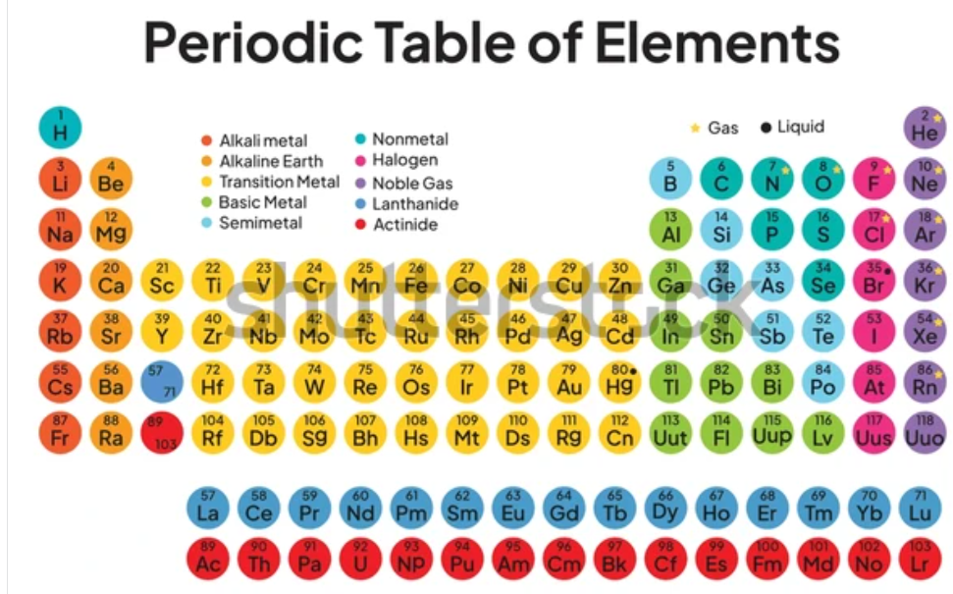

Figure 5.1- The periodic table of elements

## <H1> **Chapter Essential Questions**

How was the periodic table developed, and why is it an essential tool in chemistry?

How can the position of an element on the periodic table help us in predicting its properties and behavior?

What are the periodic trends, and how do they explain the similarities and differences between elements?

## <H1> **Chapter Big Idea**

In the periodic table, elements are organized according to their atomic numbers where after every octet fulfillment of the outermost electron shell, the recurrence of physical as well as chemical properties take place. This allows the scientists to predict the properties and behaviors of elements easily.

## <H1> **Chapter Exploration: Different Types of Salt**

Three salts are commonly used to clear the roads of ice. Sodium chloride, magnesium chloride, and calcium chloride. Do you notice that all of these contain “chloride?” But all also contain another element: sodium, magnesium, or calcium. What qualities do these elements have in common? Is there a way to predict which elements have similar properties?

<H1> **Chapter STEM Task**

Investigate how the properties of elements change across the periodic table. Design an experiment to explore how the position of an element (e.g., sodium, magnesium, or calcium) affects its chemical behavior. Use your findings to predict which elements might be effective in specific situations.

## <H1> **Chapter Overview**

Lesson 1: The Development of the Periodic Table

Lesson 2: Classifying Elements

Lesson 3: Periodic Trends and Predicting Properties of Elements

# **Chapter Wrap Up**

## <H1> **Summary**

* The periodic table was developed by arranging elements based on their atomic mass by Dmitri Mendeleev but later the table was arranged according to the atomic number of the element.
* Elements are classified as metals, nonmetals, and metalloids, and organized into specific groups and periods.
* The position of an element on the periodic table can be predicted by its chemical properties, such as reactivity and bonding behavior.
* Periodic trends, including atomic radius, ionization energy, electronegativity, and electron affinity help to explain why certain elements behave similarly.
* Elements in the same group share similar chemical properties because they have the same number of valence electrons.
* The periodic table can be used to predict which elements would react with each other and how strongly.
* Understanding chemical trends helps explain practical applications, like why certain salts are used to de-ice roads during winter.

## **<H1> Continuing the Exploration**

Throughout this chapter, you explored the periodic table and its trends. The key lies in the position of the elements, which reveals patterns that help to predict the properties of these elements. Just as sodium, magnesium, and calcium share similarities due to their position on the table, other elements with similar properties can also be identified using periodic trends. This understanding allows us to predict and explain real-world chemical behaviors, such as why specific materials are chosen for construction or manufacturing.

## <H1> **Extended STEM Activity**

Task: Construct a 3D periodic table that highlights the fact that all lanthanides and actinides share similar properties as lanthanum and actinium.

## <H1> **Bring It Together!**

In this chapter, you set out to understand the structure and purpose of the periodic table, starting with its historical development in Lesson 1. By learning how the table was organized, you gained insight into why elements were arranged in this certain way. Lesson 2 deepened your understanding by explaining how elements are classified into groups and periods, helping you see the relationships between them. Finally, in Lesson 3, you explored periodic trends and learned how to predict the properties and behaviors of elements based on their position on the table. These concepts collectively help to explain real-world applications, like how materials are selected for various purposes.

## <H1> **Chapter Reflective Journal**

Reflect on what you learned about the periodic table and chemical trends. Write down key insights you gained from this chapter.